**EXPERIMENT 7**

DQL COMMANDS (COLLEGE SCHEMA)

**Aim:**

* Display student id and marks from the student table.
* Display faculty id and name from the faculty table.
* Display who got grade A.
* Display whose marks are less than 50.
* Display the female students whose marks are between 50 to 60.
* Delete the failed students.
* Display activity id and name using object.
* Add course to student table then insert values. Display student id, faculty id using course name condition with object.
* Change mark to 50 whose id is 506
* Change name whose id is 503
* Change activity name whose id between 5 to 7
* Change department section to A whose id is less than 5
* Delete row who has id 3
* Select student name and activity name from student and activity table
* Select student name and mark from student and faculty name from faculty and course name from course
* Select department name starting from ‘c’ and faculty name ending with ‘ e’.
* Select activity having characters between ‘s-g’.
* Display students list descending order of student id
* Display faculty name ascending order of faculty id
* Display students list based on grade
* Display students having grade A using group by
* Group by faculty id and display.
* Display the students list whose grade is A using having.
* Display the faculty list who are teaching DBMS.
* Apply aggregate functions in student marks - max, min, sum, count, avg.

**Queries:**

* Display 1 to 5 students details
* Display who got grade A
* 
* 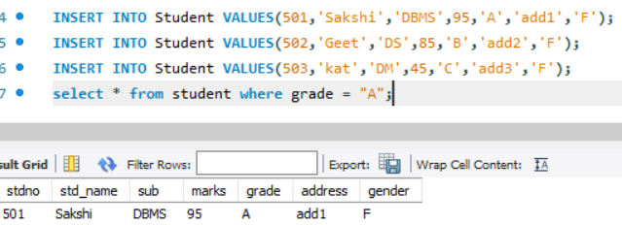
* 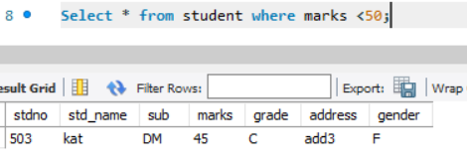
* 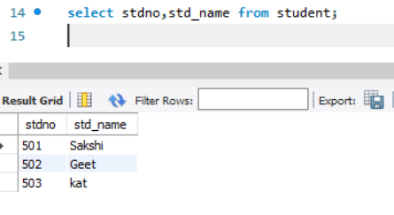
* 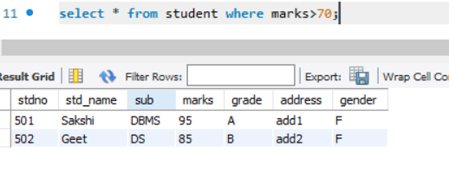
* 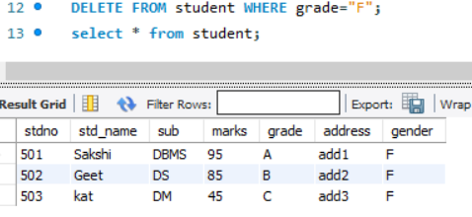
* 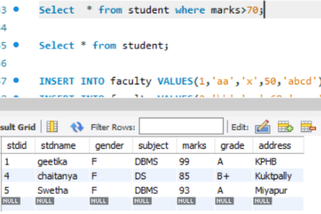
* 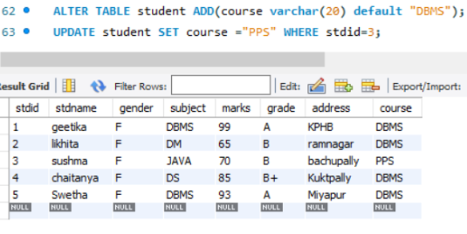
* 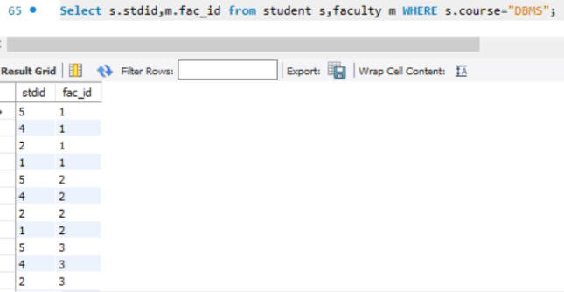
* 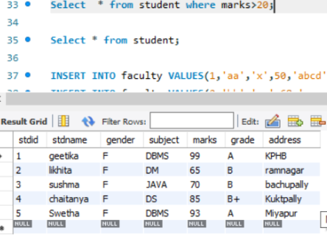
* 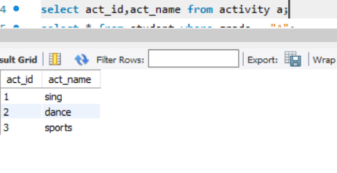

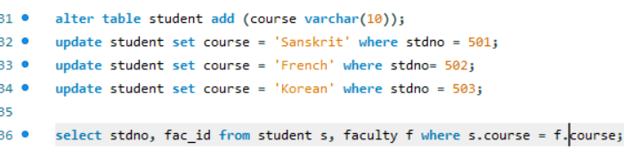

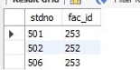

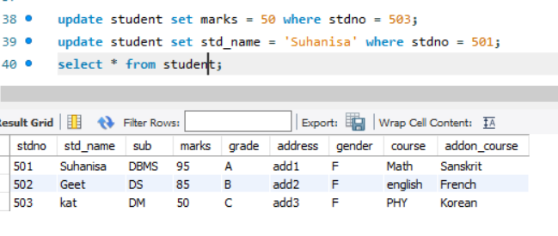

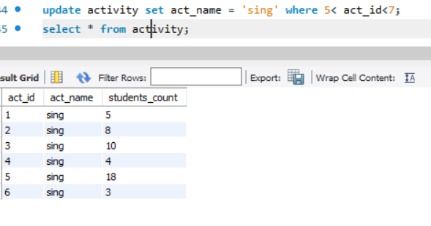

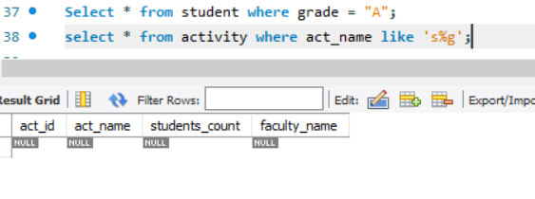

s

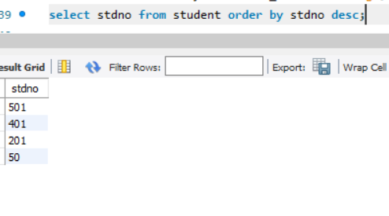

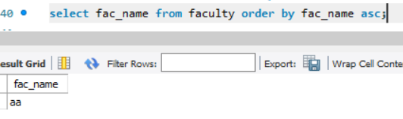

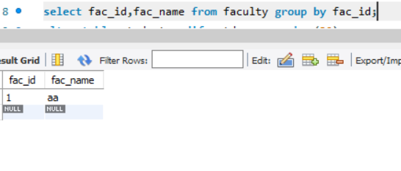

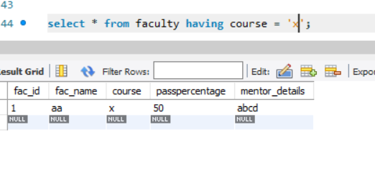

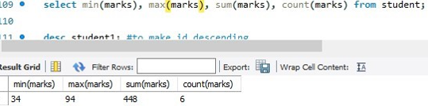

s